|  |  |
| --- | --- |
| **A249 – closure for Stockbury roundabout line painting** | Customer Contact Centre: **0300 123 5000** info@highwaysengland.co.uk[www.highwaysengland.co.uk](http://www.highwaysengland.co.uk) 5 Eclipse Park  Sittingbourne Road  Maidstone  Kent  ME14 3EN  7 September 2022 |

Dear Customer,

**A249 – closure for Stockbury roundabout line painting**

Following feedback from the local community and stakeholders, we’re going to take the opportunity to refresh the white lines on the Stockbury roundabout ahead of the slip road closures starting on Monday 12 September. To do this, we’ll be closing all links to and from the Stockbury roundabout overnight on Sunday 11 September.

When the roundabout reopens at 5am on Monday 12 September, the M2 eastbound on and off slips will remain closed as originally planned.

**Closure information:**  
To keep everyone safe, we’ll be closing the M2 eastbound on and off slips at junction 5 from **8pm Sunday 11 September** to set up traffic management. These will remain closed until Friday 13 January 2023. Please use signed diversions to join or leave the M2 at junction 5. You can find more information about our closures of the M2 junction 5 eastbound on and off slips, including diversion routes, on our project website: [nationalhighways.co.uk/M2-j5](https://nationalhighways.co.uk/our-roads/south-east/m2-junction-5-improvements/).

**The following will then also be closed from 11pm Sunday 11 September to 5am Monday 12 September,** please use signed diversions for best alternative routes:

1. M20 junction 7 slip road onto the A249 towards Sittingbourne – for anyone with direct access off the A249 and the industrial estate, access will be maintained. When going to or leaving you property, please approach closure point for an escort to an appropriate point. This is for access only; we will not be allowing any traffic to cross the roundabout.
2. M2 junction 5 westbound on and off slips to the Stockbury roundabout
3. A249 southbound (towards Maidstone) between the Bobbing to Stockbury roundabouts.
4. Chestnut Street closed between Key Street and the Stockbury roundabout – access will be maintained for residents, with an escort for properties beyond Wormdale Hill towards Maidstone.

**Diversions**During the overnight closure there will be two diversions in place.

**Motorway traffic:**

There will be a diversion running in both directions, for anyone travelling between the M2 and Bobbing/Sheerness, along the A2, Hoath Way and M2 junction 4.

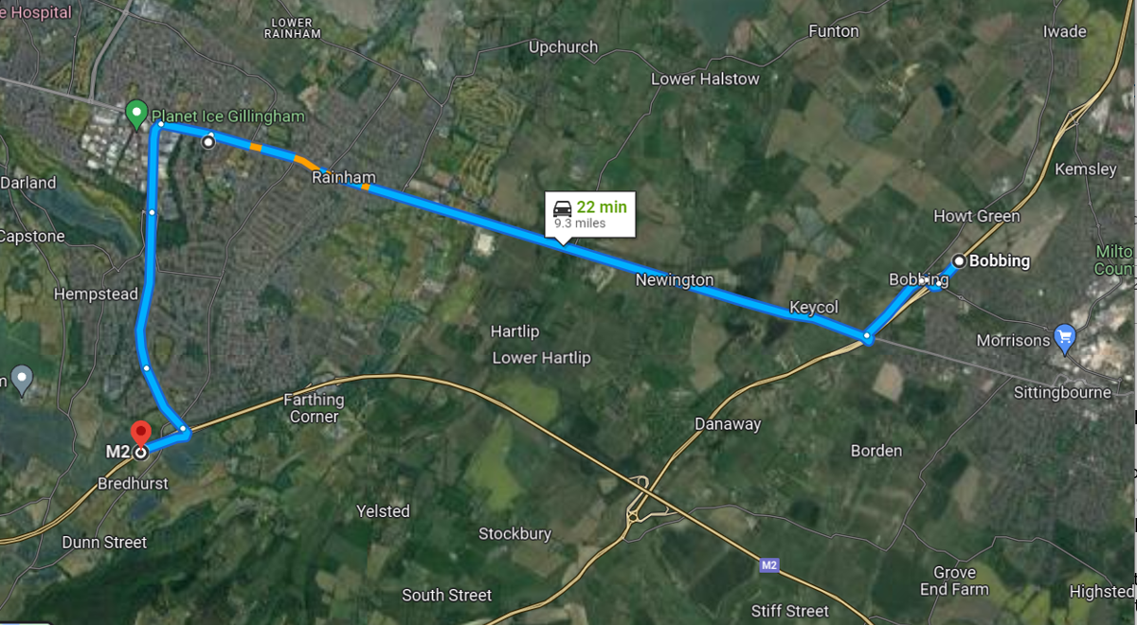

**Non-motorway traffic:**

For non-motorway traffic, there will be a diversion running in both directions along the A2 and A229 Blue Bell Hill to Maidstone, where you can join the A249 and continue your journey.

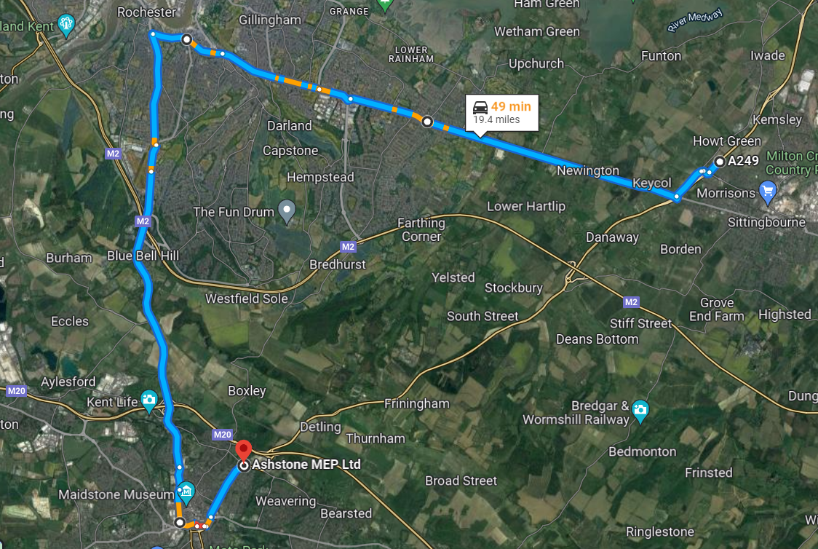

**Please note that these works are subject to change due to weather conditions or unforeseen circumstances.**

We would like to apologise in advance for any inconvenience or disruption you may experience during this work, we’re doing it now to reduce the need for further closures in the future.

If you have any questions, or if you would like to know about our work, please contact us on **0300 123 5000** or email [info@nationalhighways.co.uk](mailto:info@nationalhighways.co.uk). You can also find the latest information, on our Twitter: @HighwaysSEast or visit: [nationahighways.co.uk/travel-updates/daily-closure-report/](https://highwaysengland.co.uk/travel-updates/daily-closure-report/).

Yours faithfully

Area 4 Communications Team